October, 2012 | Volume 1 Issue 4
Changing the world one mind at a time. | CONSCIOUS LIVING NEWS
 | Yogatsu Institute for Conscious Living and Healing Studies
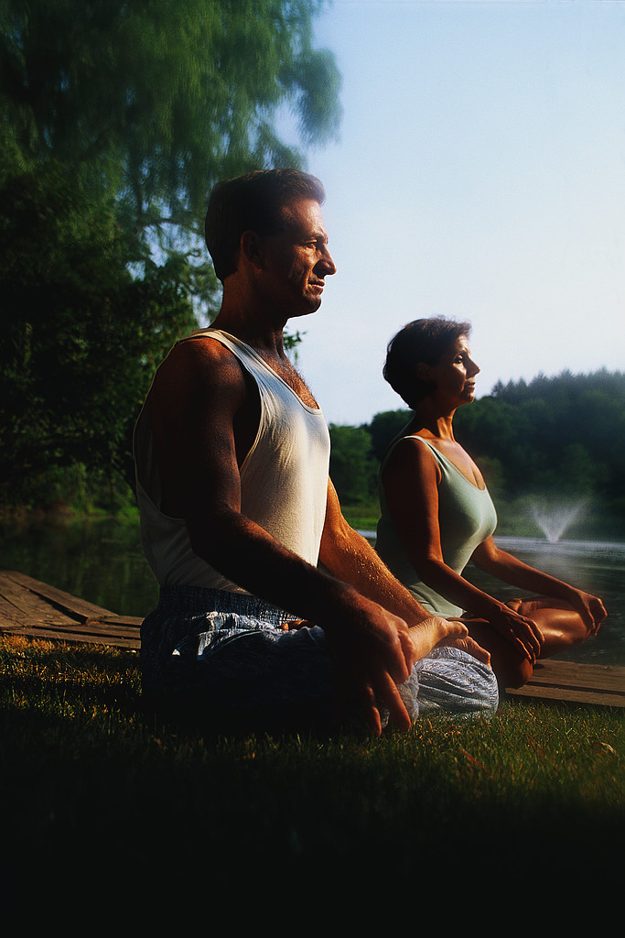  In This Issue  - Impermanence  - Meditation  - Reiki  - Michele’s Word of the Month  - Therapeutic Yoga  - Upcoming events (see last page)  Classes and Services  Therapeutic Yoga Sessions  Dates: Oct. 1, 8, 15, 22  Time: 5:30-6:30 PM  Fee: $25.00 per class (1-4 students)  Yogatsu Therapy  -$145.00 first session (90 min.,  includes evaluation)  -$125.00 thereafter (60 min.)  Reiki Sessions  Michele Ficano  -30 min. $35.00  -45 min. $55.00  -60 min. $75.00  *10% discount for 3 or more  pre-booked sessions.  About Us  Yogatsu Institute for Conscious Living and Healing Studies  Located at:  Chiropractic Healing Center  7259 Peak Dr. Ste. 106  Las Vegas, Nv. 89128  702-215-2090  Alice Percy Strauss  Director Yogatsu Institute  Yoga Alliance:  - E-RYT 500  -Yoga Alliance School 200  IAYT:  (International Association of Yoga Therapists)  -IAYT Certified School  NTCB  (Natural Therapies Certification Board)  -Board Member  -Master Instructor :  -Acupressure  -Shiatsu  -Reflexology  Cell: 702-504-5602  Email: YogaFlash@gmail.com  Web: YogatsuInstitute.com  FaceBook: TheYogatsuInstitute  Michele Ficano  Reiki Master  Certified In-tu-it Yoga Teacher  Member of Yoga Alliance  Cell: 702-499-0368  Email: Michele.S.Ficano@gmail.com  Located inside the  Chiropractic Healing Center  at:  7259 Peak Dr. Ste. 106  Las Vegas, Nv. 89128  702-215-2090  Upcoming Events  Introducing  Dharma Charms and Karma Beads  Self-awareness Jewelry and Meditation Tools  Theme: The Power of Feminine Energy  Occasion: Gathering of friends to have fun, share, and inform:  - Mini workshop: Chakras and Related Gemstones  -Showcasing Chakra Jewelry  - Mini workshop: Meditation  -Showcasing Meditation Malas  - Mini workshop: Pendulums  -Showcasing Pendulums for Intuition  - Mini workshop: Reiki  -Healing with Reiki Energy  When: Saturday, Nov. 10th  Time: 2-5 P.M.  Where: Los Prados Country Club  5150 Los Prados Circle  Las Vegas, Nv. 89130  * Free Admission | “Someday change will be accepted as life itself.  -Shirley Maclaine  The Gift of Impermanence  There is a unique grace and exquisiteness about impermanence. When something changes or dies, something else is given space to present itself, to develop, to thrive. Without the constant cycle of impermanence, life would be the same everyday—predictable, inert, stunted, unimaginative, underdeveloped, unproductive, and boring.  Rationally we understand that change is inevitable and that nothing lasts forever. Despite this we suffer immensely by clinging to the unconscious hope that somehow, someway science will declare that they were mistaken and that life can exist happily and beautifully without impermanence—allowing all that we love to remain the same.  Fearing impermanence does little good; it is a part of the cosmos that will not, and cannot, go away. Impermanence gives life value. Every flower, every pain, every kindness, every rainy day, every illness, every loss, every sound of laughter, every crisis, and every tender moment becomes noteworthy and important because we know that; “This too shall pass,” that tomorrow the sun will rise to a new day.  Meditation  Meditation with a mantra (repetition of sacred words or syllables) keeps the conscious mind focused and connected to the moment. It also helps calm the nervous system, quells mental and emotional turbulence, and aids regulation of brain function.  - Find a comfortable seated position, and turn your attention to your breath.  - On an inhalation repeat the syllable Sa, softly and out loud, or in your head. On the exhalation repeat the syllable Ha.  - Arrange and repeat these two syllables as Soham (breath grounded to earth), or Hamsa (breath floating up to the heavens) according to your present need.  Word of the Month  -Michele Ficano  Mantra  Origin: India, Sanskrit language: speech, instrument of thought.  Definition: Any often repeated word, phrase, or slogan. (In Hinduism, Buddhism, Christianity, and other religions a sacred word or prayer is repeated as an incantation.)  The word "mantra" is derived from two Sanskrit words. The first is "manas" or "mind.” The second is drawn from the Sanskrit word "trai" meaning to "protect" or to "free from." Therefore the word mantra literally means: “free from the mind." Mantra meditation can free one from the many distractions of mind because it requires focused concentration on the chosen word or phrase. The journey from mantra to this freedom is wondrous yet can be challenging. During mantra meditation the mind will expand to a depth that allows us to dip into the pool of cosmic consciousness wherein the mind accepts and understands the vibrational essence of everything. Words are powerful. And in the case of mantra this power is tangible and wieldable. Words have creative energy; creating physical vibrations that affect everyone and everything. Every sincerely intended mantra will vibrate at the same frequency as the meaning we’ve attached to it, creating grooves in our psyche that motivate the way we live. All words vibrate with powerful creative energy. That said, we must choose them wisely.  My Pathless Path to Becoming a Reiki Master  -Michele Ficano  The practice of Reiki beckoned me last July after a rigorous seven months of surgeries, healing, and more surgeries. I sought Reiki treatments before and after the surgeries, helping me release fear and remain positive. At that crucial time in my life I didn’t realize that Reiki would not only help my body heal, it would become the catalyst for my spiritual reawakening, and the motivation for studying and receiving my Reiki Master III level, enabling me to teach what I’ve grown to love.  Reiki does not automatically occur, nor does it force itself upon us. It respects our free will yet it requires time, effort, diligence, and a sincere willingness to continue growing spiritually. It is not a magic panacea. As Reiki energy begins to flow throughout our being, we must accept all possibilities, and recognize and release the negative beliefs that limit our happiness and health. Clear, sincere intentions with Reiki can guide us to many healing and spiritual experiences, even when we aren’t giving or receiving its energy.  What I want to offer my students is the understanding that you are a conduit for Reiki energy and its precious knowledge. The ego is very powerful, and only by letting go of it can true Reiki healing occur. My Reiki teachers repeated often: “When ego goes, Reiki flows.” Reiki energy can be an endless source of bliss when it is respected, and when it is shared with pure intention, optimism, and sincere compassion.  My path to becoming a Reiki Master is just beginning. I look forward to teaching Reiki and sharing its grace. I will continue to learn and grow, and when I falter I will accept it graciously, avoiding any bruising of the ego. No expectations, just good intentions.  I love the possibilities that lie ahead in my teaching career. I truly believe that when the student is ready the teacher will appear, and when the teacher is ready the student will appear—universal consciousness weaving its magic serendipitously behind the scenes. Thank you to my Reiki teachers. You will always have my respect and love. Namaste.  Therapeutic Yoga  Before we begin discussing the therapeutic focus of this month’s issue, I would like to remind our readers that Therapeutic Yoga is an all encompassing, in depth aspect of yoga that is not typically taught in most posture-oriented yoga classes. The absence of symptoms is in no way equated with health in Therapeutic Yoga. Health extends far beyond not having a headache or knee pain, or even being cured of cancer. It’s about optimizing the function of every system in your body. It’s about mental flexibility, emotional wellbeing, spiritual resilience and buoyancy, personal awareness, responsibility and accountability for the safety and care of self and others, healthy relationships, and even joy. It is only when these elements are aligned and applied into all areas of our lives that healing and good health remain at a maximal level—the goal of Therapeutic Yoga.  Seasonal change, a good example of impermanence, alters the climate, temperature, and foliage in most parts of the country. If the seasons affect you, Easy Sitting Pose with Alternate Nostril Breathing and Spinal Twist are excellent for lessening the side effects created by overproduction of histamine; a naturally occurring chemical that washes out foreign materials entering the respiratory system, nose, sinuses, and eyes.  One of the most important things to remember when experiencing the discomfort of allergens is that the immune system works best when the mind is calm and the body restful. Therapeutic, restorative yoga releases tension from the body while quieting the extraneous thoughts that run rampant in our heads, causing mental stress, tension and contraction in the physical body, and hypersensitive emotions.  Easy Sitting Pose with Alternate Nostril Breathing  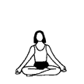  - Sit on folded blanket with thighs and legs folded together, hanging off the blanket. This lifts the spinal column and chest cavity without effort. If hips are tight place small pillow or block under knees.  - Make sure you sit tall, keep chest lifted, and move shoulder blades back toward the spine as this opens the chest and creates fluid, smooth breathing.  - Place right thumb on right nostril to close it. Breathe in and out through left nostril. Then with tip of right ring finger, close left nostril and breathe in and out through right nostril. Repeat for 2 minutes and add time as you become more comfortable. End by breathing out through left nostril.  Spinal Twist  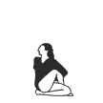  - Sit on the edge of a folded towel to lift the spinal column and expand and open chest cavity.  - Fold your left foot under your right upper thigh. Place right foot to outside of left thigh, as shown.  - On an inhalation lift chest tall. On exhalation begin moving right shoulder blade back. Feel right shoulder, upper chest, and ribcage slowly move into the twist. Last, turn your head and eyes to face back wall. Keep spine tall, chest lifted while breathing slowly and easily Hold for 3 full, relaxed breaths, and then release. Repeat on other side.

